|  |
| --- |
|  |
| Sort The Blocks |
|  |
|  |
| **Medhat Alhaddad - Basil Essam** |
|  |

|  |
| --- |
|  |

**Use Case:**

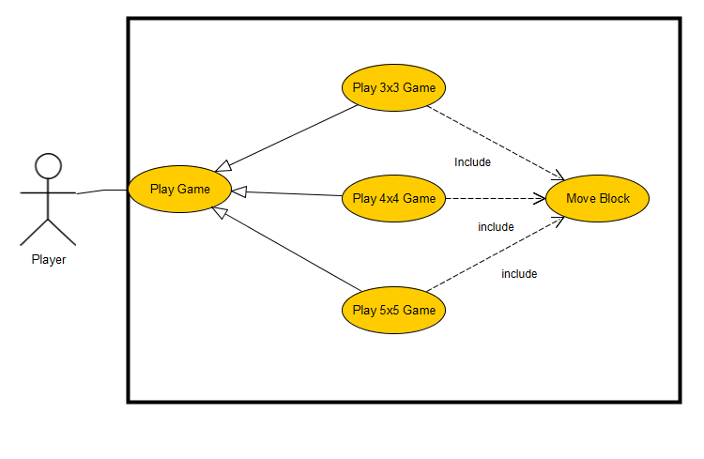

**Use Case Description:**

|  |  |
| --- | --- |
| Use Case Name | Play Game |
| Goal in Context | The player gets to start the game |
| Pre-Conditions | The player should run the game |
| Successful End Conditions | The game starts and the player starts playing |
| Failure End Conditions | The game does not start |
| Primary Actors | Player |
| Secondary Actors | None |
| Trigger | The Player wants to play the game |
| Main Flow | 1- The player runs the game  2- The player Gets to choose a game type  3- The player enters the game  4- The player moves the blocks  5- The player sorts the blocks in ascending order  6- The player wins the game  7- The player’s score is displayed  8- The game ends |
| Extensions | 5.1 The player give up on sorting the blocks  5.2 The player exits the game |
|  |  |

|  |  |
| --- | --- |
| Use Case Name | Play 3x3 Game |
| Goal in Context | The player gets to start a 3x3 game |
| Pre-Conditions | The player should run the game |
| Successful End Conditions | The game starts and the player starts playing |
| Failure End Conditions | The game does not start |
| Primary Actors | Player |
| Secondary Actors | None |
| Trigger | The Player wants to play a 3x3 game |
| Included Cases | Move Block |
| Base Use Cases | Play Game |
| Main Flow | 1- The player runs the game  2- The player Gets to choose a game type  3- The player chooses a 3x3 game  4- The player enters the game  5- The player moves the blocks  6- The player sorts the blocks in ascending order  7- The player wins the game  8- The player’s score is displayed  9- The game ends |
| Extensions | 6.1 The player give up on sorting the blocks  6.2 The player exits the game |

|  |  |
| --- | --- |
| Use Case Name | Play 4x4 Game |
| Goal in Context | The player gets to start a 4x4 game |
| Pre-Conditions | The player should run the game |
| Successful End Conditions | The game starts and the player starts playing |
| Failure End Conditions | The game does not start |
| Primary Actors | Player |
| Secondary Actors | None |
| Trigger | The Player wants to play a 4x4 game |
| Included Cases | Move Block |
| Base Use Cases | Play Game |
| Main Flow | 1- The player runs the game  2- The player Gets to choose a game type  3- The player chooses a 4x4 game  4- The player enters the game  5- The player moves the blocks  6- The player sorts the blocks in ascending order  7- The player wins the game  8- The player’s score is displayed  9- The game ends |
| Extensions | 6.1 The player give up on sorting the blocks  6.2 The player exits the game |

|  |  |
| --- | --- |
| Use Case Name | Play 5x5Game |
| Goal in Context | The player gets to start a 5x5 game |
| Pre-Conditions | The player should run the game |
| Successful End Conditions | The game starts and the player starts playing |
| Failure End Conditions | The game does not start |
| Primary Actors | Player |
| Secondary Actors | None |
| Trigger | The Player wants to play a 5x5 game |
| Included Cases | Move Block |
| Base Use Cases | Play Game |
| Main Flow | 1- The player runs the game  2- The player Gets to choose a game type  3- The player chooses a 5x5game  4- The player enters the game  5- The player moves the blocks  6- The player sorts the blocks in ascending order  7- The player wins the game  8- The player’s score is displayed  9- The game ends |
| Extensions | 6.1 The player give up on sorting the blocks  6.2 The player exits the game |

|  |  |
| --- | --- |
| Use Case Name | Move Block |
| Goal in Context | The player wants to push the block in the blank area |
| Pre-Conditions | A blank area around the selected block exists |
| Successful End Conditions | The block is placed into the blank area |
| Failure End Conditions | The block stays in its place |
| Primary Actors | Player |
| Secondary Actors | None |
| Trigger | The player clicks on the block |
| Main Flow | 1- The player starts a game of any type  2- The player clicks on the block  3- The block is replaced with the very adjacent blank area |
| Extensions | 2.1 The block is not moved as there is blocks all around it (no blank adjacent area) |

